Adeline Akansobe, Yu-Yun Ruan, Clio Bate, and Esha Bharadwaj

Final Report: Simulating Alternations for Temporary Crops

GEOG360: GIS and Land Change Models

December 20, 2023

**Simulating Alternations for Temporary Crops**

**Research Objectives:**

The objective of this research is to simulate gross gains and losses and attempt to simulate alternations for the time interval of 2000 to 2020 using temporary crop data from Bahia, Brazil using TerrSet’s Land Change Modeler (LCM).

**Final Product:**

This document serves as our final product, a report on the software issues encountered during the analysis, including striping/banding, masking, and other errors, to Clark Labs.

**Data and Methodology:**

The study area is the state of Bahia in Brazil. All the data is at a resolution of 120 meters. All the Bahia municipalities were masked to make sure all the simulated change occurs within Bahia. All the input variables were also similarly masked for the same reason. The Multi-Layer-Perceptron (MLP) sub-model in TerrSet’s Land Change Modeler (LCM) was used to run the analysis. A calibration of 10 years, with 1990 as the input for the earlier image, and 2000 as the input for the later image, were the inputs for the LCM. The process included two recalculation stages at ten-year intervals: 2000 to 2010, and 2010 to 2020. All variables were grouped together, and the Markov matrix was in default setting. The variables used in this project are:

* Distance to Change (DTC), 1990 – used as both static and dynamic variables
* Elevation – used as a static variable
* Slope – used as a static variable

Five runs were simulated in MLP using different combinations of the variables:

1. Run 1: used one variable, distance to change as static variable
2. Run 2: used two variables, distance to change as static variable, and elevation as static variable
3. Run 3: used one variable, distance to change as dynamic variable
4. Run 4: used two variables, distance to change as dynamic variable and elevation as static variable
5. Run 5: used three variables, distance to change as dynamic variable, elevation as static variable, and slope as static variables

|  |  |  |  |  |
| --- | --- | --- | --- | --- |
| **Run** | **Number of Variables** | **Variable 1** | **Variable 2** | **Variable 3** |
| Run 1 | 1 | Distance to Change (static) |  |  |
| Run 2 | 2 | Distance to Change (static) | Elevation (static) |  |
| Run 3 | 1 | Distance to Change (dynamic) |  |  |
| Run 4 | 2 | Distance to Change (dynamic) | Elevation (static) |  |
| Run 5 | 3 | Distance to Change (dynamic) | Elevation (static) | Slope (static) |

Table 1: All five run simulations

Fig 1: Study area – Bahia, Brazil Fig 2: Crosstab of temporary crops 1990 and temporary crops 2000

Fig 3: Default Markov Matrix used in all runs

Fig 4: Masked images of variables from left to right (a) Distance to Change, (b) Elevation, (c) Slope

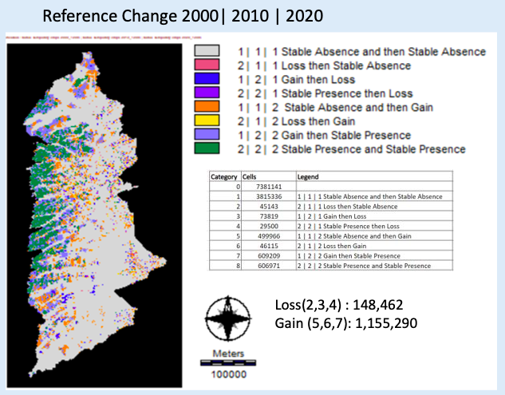

Fig 5: Crosstab showing Reference Change

**Results:**

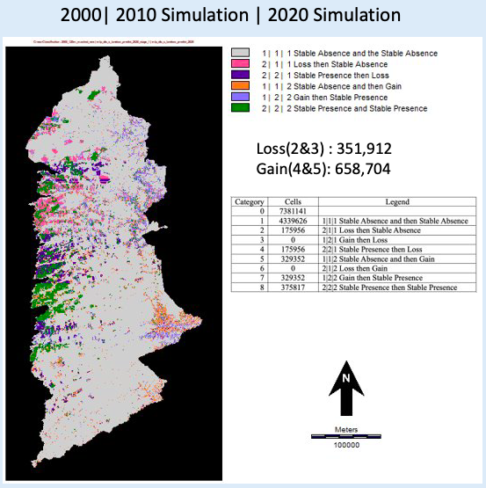

Fig 6: Crosstab of simulation for Run 1, DTC as static variable

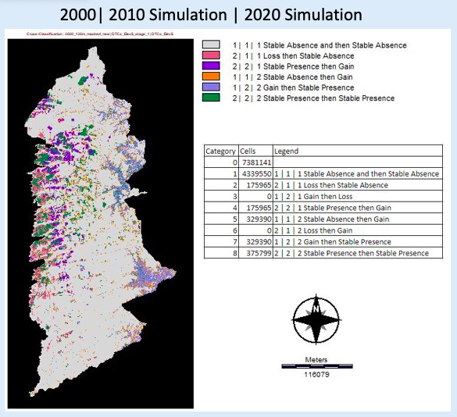

Fig 7: Crosstab of simulation for Run 2, DTC and Elevation as static variables

Fig 8: Crosstab of simulation for Run 3, DTC as dynamic variable